Aim: To understand the concept of Threading and single,multi Tasking.
Threading in Python:
Input:
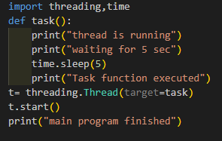
Output:
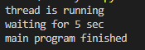
- Single tasking: B. Multitasking:
Input: Input:
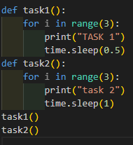
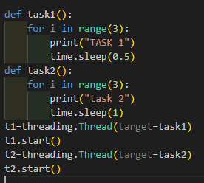
Ouput: Output:
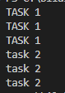
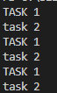

Examples:
Single tasking:
Input:
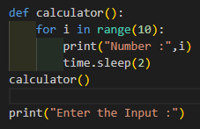
Output:
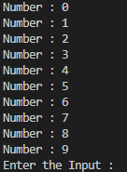
Multitasking:
Input:
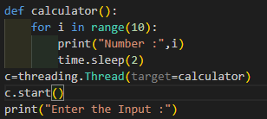
Ouput:
